LAB # 11
Introduction to Test Suite
Lab Task: Make a class having four functions for determining,
• Whether the input integer is odd.
• Whether the input integer is even.
• Whether the input integer is prime.
• For calculating the factorial of that input integer.
Write their test cases and execute them in a single test suite class. Follow all the steps mentioned above in the manual.
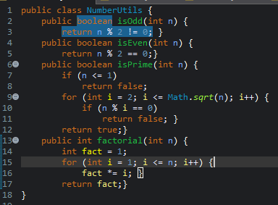

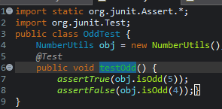

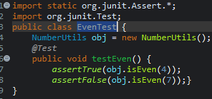

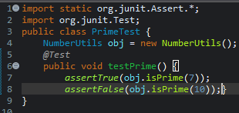

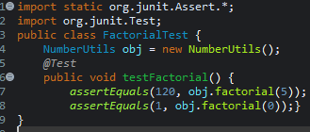
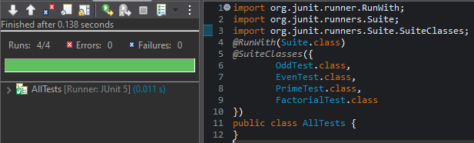

GITHUB SCREENSHOT:

